PEWPEW BLASTER

(A microbit game by Mohamed Migdhadh)

This is a very simple game. The player is controlling a spaceship that’s going trough space which encounters space aliens. The objective is to avoid getting hit by the incoming waves of aliens. You can shoot Lazer missiles to shoot down enemies and score points. Once you get hit by an alien it game over and you will be shown a sad face and the microbit device will say “GAME OVER” after which you accumulated score is displayed.

Controls:

1. You can use the accelerometer to moved left and right.

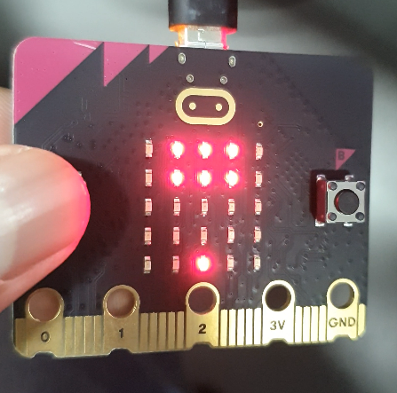

(In stationary starting position)

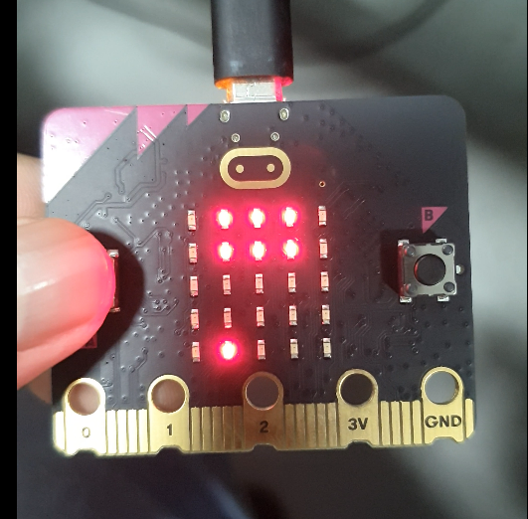

(When the device is tilted left)

(When the device is tilted right)

1. When you press button A you will shoot a Lazer missile will be shot from your current location.

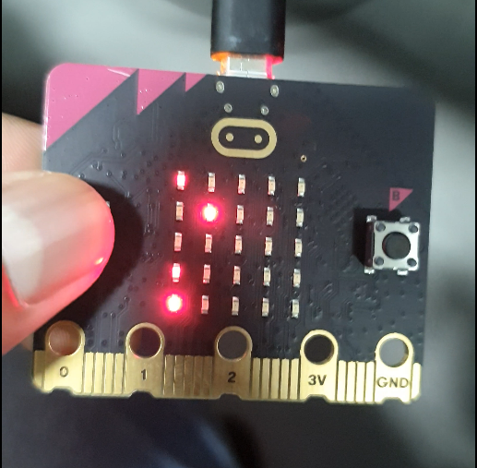

1. When you press button B you will shoot a bomb which will wipe out some of the aliens on screen.

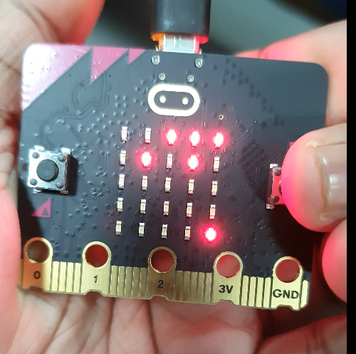

(Before button B is pressed)

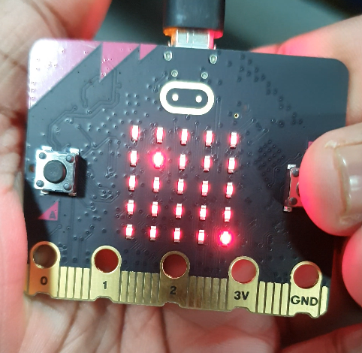

(Once B is pressed the bomb detonates)

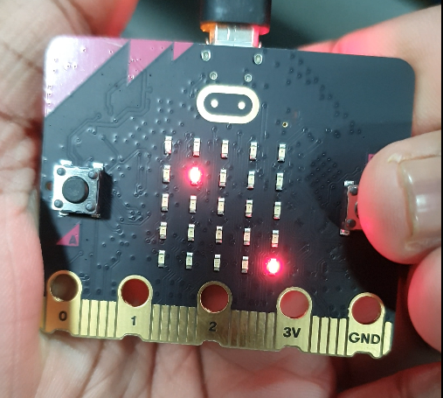

(The bomb has wiped out most of the aliens)